A
TECHNICAL SEMINAR REPORT
ON

NEURALINK
Submitted in partial fulfilment of the requirements for the award of the degree of
BACHELOR OF TECHNOLOGY
In
CSE (ARTIFICIAL INTELLIGENCE AND MACHINE LEARNING)
Submitted By
D.Likhitha Mahalaxmi (20UP1A6611)



DEPARTMENT OF CSE ( ARTIFICIAL INTELLIGENCE AND MACHINE LEARNING)
VIGNAN’S INSTITUTE OF MANAGEMENT AND TECHNOLOGY
FOR WOMEN
Accredited to NBA (CSE & ECE)
(Affiliated to Jawaharlal Nehru Technological University Hyderabad)
Kondapur (Village), Ghatkesar (Mandal), Medchal (Dist.), Telangana
Pincode-501301
2020 - 2024


VIGNAN’S INSTITUTE OF MANAGEMENT AND
TECHNOLOGY FOR WOMEN

DEPARTMENT OF CSE (AI & ML)
CERTIFICATE

This is to certify that Technical Report entitled “NEURALINK” submitted by D.LIKHITHA MAHALAXMI (20UP1A6611), in the partial fulfillment of the requirements for the award of the degree of Bachelor of Technology in CSE (Artificial Intelligence and Machine Learning) VIGNAN’S INSTITUTE OF MANAGEMENT AND TECHNOLOGY FOR WOMEN is a record of bonafide work carried by her under my guidance and supervision. The results embodied in this report have not been submitted to any other University or institute for the award of any degree.

Mrs. B. Sangeetha Dr. S. Ranga Swamy
Assistant Professor Associate Professor &
Technical Seminar Guide Head Of The Department



VIGNAN’S INSTITUTE OF MANAGEMENT AND TECHNOLOGY FOR WOMEN

DEPARTMENT OF CSE (AI & ML)

DECLARATION

We here by declare that Technical Seminar entitled “NEURALINK” is bonafied work duly completed by me. It does not contain any part of the Seminar or that is submitted by any other candidate to this or another institute of the university. All such materials that have been obtained from other sources have been duly acknowledged.

D.LIKHITHA MAHALAXMI
(20UP1A6611)

ACKNOWLEDGMENT

We would like to express sincere gratitude to Dr. G. APPARAO NAIDU, Principal, Vignan’s Institute of Management and Technology for Women for his timely suggestions which helped us to complete the Technical Seminar in time.
We would also like to thank our sir, Dr. S. RANGA SWAMY, Head of the Department, CSE (Artificial Intelligence and Machine Learning), for providing us with consultant encouragement and resources which helped me to complete the Technical Seminar in time.
We would like to thank our Technical Seminar Guide, Mrs. B. Sangeetha, Assistant Professor, for her timely cooperation and valuable suggestions throughout the Seminar. We are indebted to him for the opportunity given to work under his guidance.
Our sincere thanks to all the teaching and non-teaching staff of Department of CSE (AI & ML) for their support throughout The Technical Seminar work.

D.LIKHITHA MAHALAXMI
(20UP1A6611)

ABSTRACT
Neuralink, founded by entrepreneur and innovator Elon Musk in 2016, has emerged as a groundbreaking neurotechnology company with the ambitious goal of developing advanced brain-computer interfaces (BCIs) to bridge the gap between the human brain and artificial intelligence. This abstract provides an overview of Neuralink's mission, technological advancements, potential applications, ethical considerations, and the implications of its work on the future of humanity.
Neuralink's primary objective is to create a seamless connection between the human brain and external devices by developing high-bandwidth neural interfaces. The company has made significant progress in this field, leveraging innovative surgical techniques and implantable devices to facilitate communication between neurons and external hardware. By doing so, Neuralink aims to revolutionize the way we interact with computers, enabling direct brain control over devices and opening doors to new possibilities in healthcare, communication, and human augmentation.
One of the key applications of Neuralink's technology lies in the field of medical therapeutics. The potential to treat neurological disorders, such as Parkinson's disease or epilepsy, through precise neural stimulation holds promise. Furthermore, the restoration of lost sensory or motor functions is within reach, offering hope to individuals with disabilities.
However, as Neuralink pushes the boundaries of neurotechnology, it raises significant ethical questions. Concerns regarding privacy, data security, and the potential for misuse of the technology are important considerations. Ethical frameworks must be established to safeguard the autonomy and well-being of individuals as these advancements move forward.
The emergence of Neuralink and its innovative work also poses societal and philosophical questions about the nature of consciousness, identity, and the boundary between humans and machines. As BCIs become more sophisticated, the potential for merging human cognition with artificial intelligence could fundamentally reshape our understanding of intelligence and the human experience.
In conclusion, Neuralink represents a pioneering force in the development of brain-computer interfaces. While the technology offers transformative potential in healthcare and human-machine interaction, it simultaneously presents a host of ethical and philosophical challenges. The future of Neuralink holds great promise, but its path forward requires careful navigation to ensure the responsible and ethical integration of neurotechnology into our lives.

INDEX

CONTENTS PAGE NO
.
- Introduction 1-2
  - Background of Neuralink 1
  - Purpose and Scope of the Report 2

- Brain-Machine Interfaces (BMIs) 3-5
  - What are BMIs? 3
  - The need for advanced BMIs 4
  - Neuralink's approach to BMIs 5

- Neuralink's Technology 6-10
  - Brain implant technology 6
  - Flexible threads 6
  - Neuralink's surgical robot 7
  - Brain data processing and decoding 7

- Neuralink's Goals 19-21
  - Treating neurological disorders 20
  - Enhancing human capabilities 20
  - The long-term vision: Neuralink as a symbiotic extension of the brain 20

- Current Progress 22-23
  - Animal testing and results 22
  - Human trials and regulatory approvals 22
  - Challenges and setbacks 23

- Ethical and Societal Implications 24-25
  - Privacy and security concerns 24
  - Potential misuse of brain data 24
  - Equality and accessibility issues 24
  - Public perception and acceptance 24

- Future Outlook 26-27
  - The role of Neuralink in the neurotechnology landscape 26
  - Potential applications beyond healthcare 26
  - Collaboration and competition in the BMI field 26

- Conclusion 28-29
  - Neuralink's potential to transform healthcare 28
  - Ethical considerations and responsible development 28
  - The future of Neuralink and BMIs 28

- References 29

1. INTRODUCTION:

In the realm of cutting-edge technology and neuroscience, Neuralink stands as a pioneering force on a mission to redefine the boundaries of human-computer interaction. Founded in 2016 by visionary entrepreneur Elon Musk, Neuralink is a neurotechnology company that aims to bridge the gap between the human brain and external devices through the development of advanced brain-machine interfaces (BMIs). It represents a significant leap forward in the convergence of neuroscience and artificial intelligence, with the potential to revolutionize the way we understand and harness the power of the human mind.

At its core, Neuralink seeks to unlock the mysteries of the human brain and leverage this understanding to create transformative solutions. The brain is the most intricate and complex organ in the human body, housing billions of neurons that communicate through electrical signals. Neuralink's primary objective is to decipher these neural signals, enabling bidirectional communication between the brain and external devices. By doing so, Neuralink aspires to address a wide range of critical challenges, from treating neurological disorders and enhancing human capabilities to achieving Musk's long-term vision of integrating technology seamlessly into the human experience.

Neuralink's ambitious agenda is not merely confined to the realm of science fiction; it is grounded in cutting-edge research and technological innovation. The company has developed a suite of groundbreaking technologies, including advanced brain implant technology, flexible threads for precise neural interfacing, the N1 Link device for data transmission, and a state-of-the-art surgical robot for implantation. These innovations form the foundation of Neuralink's endeavors to create BMIs that are safe, efficient, and accessible.

Figure 1 Neuralink Logo
In this technical seminar report, we will delve deep into the workings of Neuralink, examining its technological advancements, current progress, ethical implications, and the potential societal impact of its groundbreaking research. We will also explore Neuralink's goals, from addressing neurological disorders to augmenting human capabilities, and consider the broader implications of this remarkable venture in the rapidly evolving field of neurotechnology.

  - Background of Neuralink

1. Founding and Early Years (2016-2017): Elon Musk co-founded Neuralink with a team of scientists and engineers, including Max Hodak and several others. The company was initially quite secretive about its projects, but it became known that they were working on creating advanced brain-computer interfaces.
2. Initial Funding and Progress (2017-2019): Neuralink raised significant funding to support its research and development efforts. In 2017, they raised $27 million, and in 2019, they secured an additional $158 million in a funding round led by Elon Musk. During this period, they began sharing more details about their work, including their plans to develop a neural implant known as the "Neuralink device."
3. Public Demonstrations (2019-2020): Neuralink made headlines in July 2019 when they held a public event to showcase their progress. During the event, they demonstrated a prototype of their brain-machine interface system, which featured a tiny, flexible electrode array that could be implanted into the brain. They also showed a pig named Gertrude that had a Neuralink implant.
4. Progress and Ambitious Goals (2020-2021): Neuralink continued to make advancements in their technology, aiming to develop a system that could enable communication between the human brain and external devices with high precision and bandwidth. Elon Musk emphasized their ambitious goals, including the potential to treat various neurological conditions, such as Parkinson's disease and depression, and to ultimately achieve a symbiotic relationship between humans and AI.
5. Regulatory Approvals and Clinical Trials: In 2020 and 2021, Neuralink started taking steps toward conducting human trials of their brain implant technology. They received approval from the U.S. Food and Drug Administration (FDA) to implant the Neuralink device in a limited number of human participants for research purposes. These trials are intended to evaluate the safety and effectiveness of the technology.
6. Ongoing Research and Development: As of my knowledge cutoff date in September 2021, Neuralink was actively engaged in ongoing research and development efforts to refine their BCI technology and prepare for clinical trials. The company continued to hire experts in neuroscience, engineering, and other related fields to advance their mission.

1.2. Purpose and Scope of the Report
A report on Neuralink can serve various purposes and should have a defined scope depending on its intended audience and objectives. One potential purpose is to educate the readers, which could involve providing a comprehensive overview of Neuralink, encompassing its history, technology, goals, and potential implications across multiple domains, including neuroscience and human-computer interaction. Alternatively, it could aim to assess Neuralink's investment potential, delving into financial aspects, market opportunities, competitive landscape, and associated risks and rewards. A scientific report might delve into the neuroscience underpinning brain-computer interfaces, Neuralink's methodology, and the scientific advancements it could facilitate. Ethical and regulatory reports could explore the ethical considerations and regulatory frameworks governing Neuralink's work. Reports with a medical and healthcare focus might investigate potential medical applications and implications for patient care.
In terms of scope, such a report typically begins with an introduction to Neuralink, outlining its founders, history, mission, and objectives. It would then delve into the core technology, elucidating Neuralink's brain-computer interface technology, electrode arrays, neural implants, and data processing algorithms. The report may discuss the diverse applications of Neuralink's technology, ranging from medical treatments to scientific research and consumer interfaces. Additionally, it could highlight ongoing research and development efforts, recent advancements, and market analysis, including market size, competition, and growth opportunities. Ethical and regulatory considerations would address issues like privacy, informed consent, and regulatory approvals. If relevant, financial data might be included, such as revenue, funding, and profitability. Real-world case studies and examples can illustrate practical applications and benefits. Lastly, the report could conclude with a summary of key findings and offer recommendations or insights tailored to the report's specific objectives, be it investment decisions, ethical guidance, healthcare implications, or other aspects relevant to the chosen purpose and audience
.
- BRAIN-MACHINE INTERFACES (BMI’s)
A Brain-Machine Interface (BMI) is a technology that establishes a direct connection between the human brain and external devices, enabling bidirectional communication. BMIs typically involve neural recording through implanted electrodes or non-invasive sensors, followed by signal processing to decode neural activity. This decoded information can be used to control external devices like prosthetic limbs or computers, allowing users to interact with the world through their thoughts. BMIs hold potential for applications in assistive technology, neuroprosthetics, and enhancing human capabilities, although they also raise ethical and privacy considerations.
  - What are BMI’s
A Brain-Machine Interface is a technology that establishes a direct communication link between the human brain and external devices or computers. There are several types of BMIs, each with its own characteristics and applications:

TYPES OF BMI’s

1. Invasive BMIs: These BMIs involve surgically implanting electrodes or sensors directly into the brain tissue. Invasive BMIs offer high precision and the ability to record and stimulate specific neurons, making them suitable for tasks like controlling prosthetic limbs or conducting research on neural function. However, they require surgery and carry certain risks.

2. Semi-Invasive BMIs: Semi-invasive BMIs use electrodes placed on or just beneath the skull's surface but do not penetrate the brain tissue. These electrodes are often placed within the dura mater, a protective layer covering the brain. This approach reduces some of the surgical risks associated with invasive BMIs while still providing good signal quality.

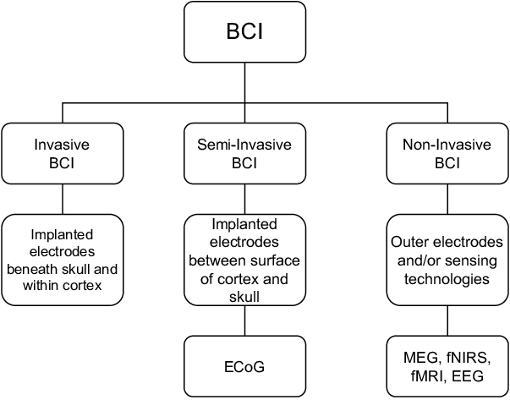
3. Non-Invasive BMIs: Non-invasive BMIs do not require any surgical procedures. Instead, they use external sensors to detect brain activity. Common non-invasive techniques include electroencephalography (EEG), functional magnetic resonance imaging (fMRI), and magnetoencephalography (MEG). Non-invasive BMIs are less precise than invasive or semi-invasive methods but are safer and easier to use. They are often used in applications like brain-computer interfaces for communication or controlling devices.
Figure 2 Types of BMI’s

4. Electrocorticography (ECoG): ECoG is a type of BMI that involves placing a grid of electrodes directly on the brain's surface, usually on the exposed cortex during brain surgery. It offers a balance between invasiveness and signal quality, making it suitable for certain applications such as epilepsy monitoring and research.

5. Optogenetics: While not a traditional BMI, optogenetics is a technique that combines genetic modification of neurons with light-based control. It allows researchers to activate or inhibit specific neurons in the brain using light, offering precise control but limited to laboratory settings and animal research.

Each type of BMI has its advantages and limitations, and the choice depends on the specific application, the need for invasiveness, and the trade-off between signal quality and safety. Advances in BMI technology continue to expand the range of possibilities for brain-computer communication and control, with potential applications in healthcare, assistive technology, research, and beyond.

  - The need for Advanced BMI’s
Advanced Brain-Machine Interfaces (BMIs) are of paramount importance due to their transformative potential in various domains. These cutting-edge interfaces hold the promise of significantly improving the lives of individuals with disabilities by restoring lost functions and enhancing their independence. Furthermore, advanced BMIs have medical applications, offering opportunities for monitoring and treating neurological conditions. They also play a crucial role in neuroscience research, aiding our understanding of the brain and contributing to the development of therapies for neurological disorders. Beyond healthcare, BMIs have the capacity to augment human capabilities, from controlling exoskeletons for enhanced mobility to interfacing directly with computers for more efficient interactions. While their long-term potential is exciting, ethical considerations surrounding privacy and security must be addressed as BMIs continue to evolve, ensuring responsible and beneficial utilization of this groundbreaking technology.

2.3. Neuralink’s approach to BMI’s
One of Neuralink's primary objectives is to harness the power of BMIs for medical applications. They are working towards enabling individuals with neurological conditions, such as paralysis, to regain control over their environment by using their thoughts to manipulate computers or prosthetic devices. Beyond this, Neuralink is exploring the potential for BMIs to treat various neurological disorders like epilepsy and depression. These therapeutic applications represent a significant step forward in healthcare, offering hope for improved patient outcomes and quality of life.
Neuralink's ambitions extend beyond just medical applications. The company envisions a future where BMIs play a central role in human augmentation, enhancing our cognitive abilities, memory, and communication. While these goals are ambitious and exciting, they also come with ethical and societal considerations, including privacy, consent, and potential inequalities in access to such technology. Neuralink has embarked on animal testing experiments, involving rodents and pigs, to demonstrate the feasibility and safety of their technology, but there are still many challenges to address as they work toward their long-term vision of achieving symbiosis between humans and artificial intelligence.

3.NEURALINK’S TECHNOLOGY
There are mainly three components involved in the Neuralink’s Technology. They are
- Implant
- Surgical Robot
- Neuralink App
A. Implant:
This brain-computer interface is fully implantable, cosmetically invisible, and designed to let people control a computer or mobile device anywhere they go.
This implant has four sub-components. They are
- Biocompatible Enclosure
- Battery
- Chips and Electronics
- Threads

Biocompatible Enclosure
The N1 implant is hermetically sealed in a biocompatible enclosure that withstands physiological conditions several times harsher than those in the human body.

Battery
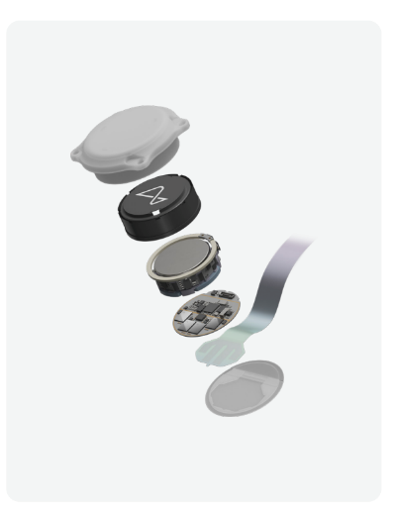
The N1 implant is powered by a small battery charged wirelessly from the outside via a compact, inductive charger that enables easy use from anywhere
Figure 3 Implant
Chips and Electronics
Advanced, custom, low-power chips and electronics process neural signals, transmitting them wirelessly to the Neuralink Application, which decodes the data stream into actions and intents.

Thread
The N1 implant records neural activity through 1024 electrodes distributed across 64 threads. These highly-flexible, ultra-thin threads are key to minimize damage during implantation and beyond.

B. Surgical Robot:
The threads of implant are so fine that they can’t be inserted by the human hand. Surgical Robot has been designed to reliably and efficiently insert these threads exactly where they need to be.
The surgical robot has three sub-components. They are
- Base Structure
- Robot Head
- Needle

Base Structure
The base structure and motion stage provide the structural platform for the robot head and the primary 3 axis linear motion used to position the robot head and needle.

Robot Head
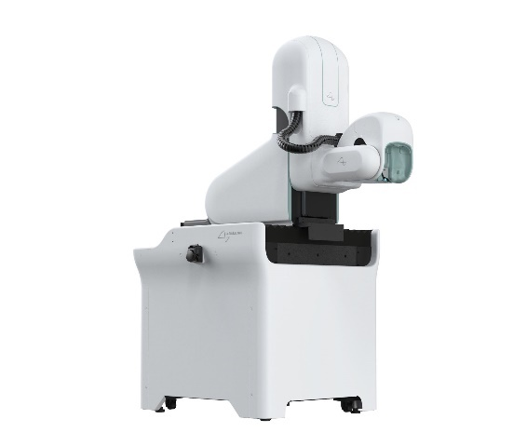
The robot head contains the optics and sensors of 5 camera systems and the optics for an optical coherence tomography (OCT) system.
Figure 4 Surgical Robot

Needle
The needle, which is thinner than a human hair, grasps, inserts, and releases threads.

C. Neuralink App:
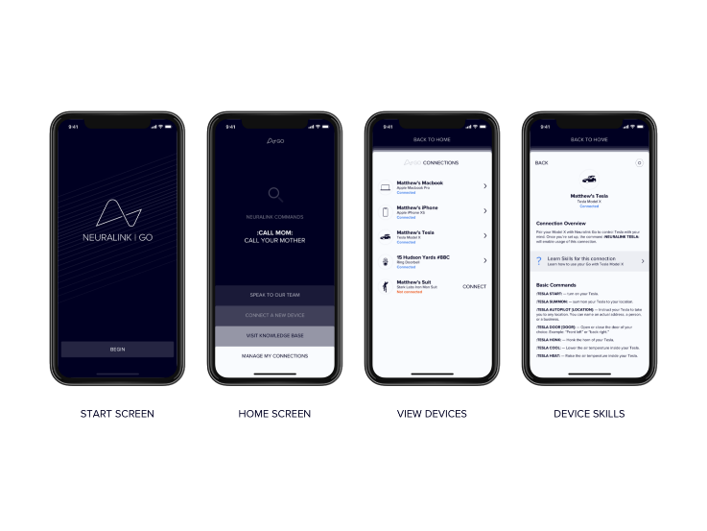
The concept of Neuralink App was to provide a user interface that would allow individuals with Neuralink implants to interact with and control the technology. It has reliable computer control and prioritizes ease of use.
Figure 5 Neuralink App

3.1. Brain Implant Technology:
Neuralink's core technology involves implanting extremely thin, flexible threads (electrodes) into the brain to record and stimulate neural activity. These threads are designed to be much finer and less invasive than traditional brain electrodes, which can minimize tissue damage and improve the long-term safety of the implant. The threads are implanted using a surgical procedure, and they are connected to a small implantable device behind the ear, which contains electronics for signal processing and wireless communication.

3.2. Flexible Threads:
Neuralink's flexible threads, often referred to as "neural threads," are a key innovation in their BCI technology. These threads are thinner than a human hair, making them less likely to cause damage to brain tissue and allowing for a more precise interface with neurons. The flexibility of these threads enables them to move with the natural movements of the brain, reducing the risk of injury or displacement over time.
3.3. Neuralink's Surgical Robot:
To implant the flexible threads accurately and safely into the brain, Neuralink developed a specialized surgical robot. This robot assists neurosurgeons in the precise placement of the threads, ensuring that they are inserted with high precision. The surgical robot is a critical component of Neuralink's technology, as it enhances the safety and reliability of the implantation procedure. It can be controlled with great precision to minimize the risks associated with invasive brain surgery.

3.4. Brain Data Processing and Decoding:
Once the electrodes are implanted and neural signals are recorded, Neuralink's technology includes advanced signal processing algorithms and machine learning techniques to decode and interpret the brain's electrical activity. The goal is to understand and translate these neural signals into meaningful commands or information that can be used to control external devices or interfaces. This aspect of Neuralink's technology is essential for enabling applications like restoring motor function in paralyzed individuals or facilitating direct brain-to-computer communication.
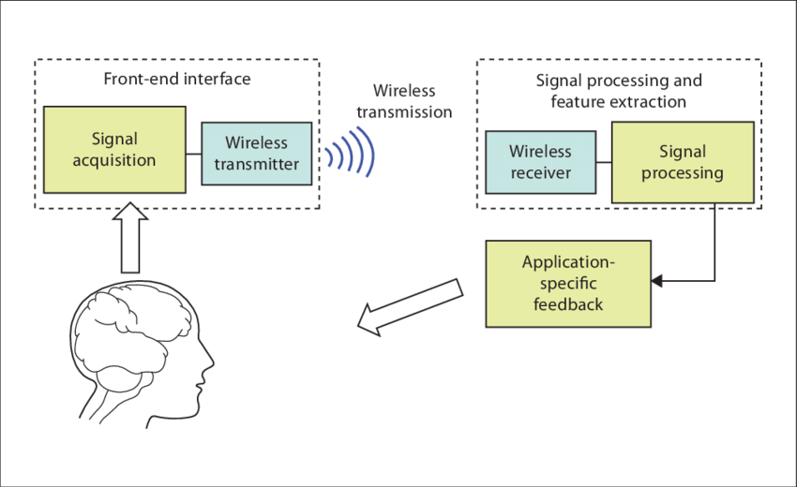
It's worth noting that Neuralink's technology is a multidisciplinary effort that combines expertise in neuroscience, neurosurgery, materials science, robotics, and software development. While they had made significant progress up to September 2021, the field of BCIs remains a complex and rapidly
Figure 6 Working of BCI's

evolving one. Neuralink's technology represents a pioneering effort in making BCIs more accessible, less invasive, and potentially transformative for both medical applications and human augmentation. To stay up-to-date on the latest developments in Neuralink's technology, it's advisable to refer to the company's official updates and news releases.

4.NEURALINK’S GOALS:
Neuralink, the brainchild of entrepreneur Elon Musk, has set ambitious goals that encompass the realm of neurotechnology and brain-computer interfaces (BCIs). At its core, Neuralink seeks to revolutionize our understanding of the human brain and its interaction with technology. One of its primary objectives is to address the pressing issue of neurological disorders. Through the development of advanced BCIs, Neuralink aims to provide effective treatments for conditions such as epilepsy, Parkinson's disease, depression, and paralysis. These BCIs would establish direct connections between the brain and external devices, potentially offering life-changing solutions for individuals battling these disorders, improving their quality of life.

Beyond addressing health challenges, Neuralink envisions BCIs as a means of enhancing human capabilities. By leveraging this technology, the company hopes to augment cognitive functions, enhance memory, and enable direct brain-to-brain communication. This could usher in a new era of education, information sharing, and human-computer interaction, where thoughts become a powerful medium for communication and knowledge exchange.

Neuralink's long-term vision extends even further, contemplating a future where BCIs create a symbiotic relationship between the human brain and artificial intelligence (AI). In this scenario, individuals could seamlessly integrate with AI systems, harnessing their capabilities while retaining their unique identity. This vision serves as a proactive response to potential scenarios where AI surpasses human intelligence, ensuring that humans can remain relevant and competitive in such a world.

In pursuing these goals, Neuralink places a strong emphasis on ethical considerations and safety. The company acknowledges the ethical implications and safety concerns inherent to BCIs. It is committed to addressing these issues responsibly, including ensuring the safety and efficacy of BCI implantation, safeguarding user privacy and data security, and grappling with the broader societal and ethical implications that may arise from widespread BCI adoption.

Neuralink's commitment to research and development is also central to its mission. The company invests significantly in advancing BCI technology, conducting experiments and clinical trials to refine and improve its capabilities. Collaboration with experts from various fields is an integral part of the company's approach, ensuring that it remains at the forefront of neurotechnology innovation.

While Neuralink has made substantial progress, it's important to recognize that the full realization of these goals is a complex and long-term endeavor. Numerous technical, regulatory, and ethical challenges lie ahead. Nonetheless, Neuralink's work represents a pioneering effort in neurotechnology, holding the potential to reshape how we interact with technology, treat neurological conditions, and navigate the evolving landscape of human-AI interaction in the years to come.

4.1. Treating Neurological Disorders:
Neuralink aims to develop advanced brain-computer interfaces to treat a wide range of neurological disorders and conditions. This includes conditions like epilepsy, Parkinson's disease, depression, and various forms of paralysis. The idea is to create a direct connection between the brain and external devices or software to help monitor and control brain activity, potentially alleviating the symptoms of these disorders.

4.2. Enhancing Human Capabilities:
Neuralink is also interested in enhancing human capabilities by leveraging BCIs. The technology has the potential to augment human cognition, memory, and communication. For example, it could enable direct communication between individuals through thoughts or facilitate the transfer of information from a computer directly into the brain. This could have applications in education, information retrieval, and even entertainment.

4.3. The Long-Term Vision: Neuralink as a Symbiotic Extension of the Brain:
Neuralink's long-term vision, as outlined by Elon Musk, is to create a symbiotic relationship between the human brain and artificial intelligence (AI). The idea is to develop BCIs that seamlessly integrate with the brain, allowing humans to merge with AI and access its capabilities while retaining their individuality. This vision includes the possibility of addressing potential future scenarios where AI might surpass human intelligence. Neuralink aims to ensure that humans can remain relevant and competitive in such a world.
To achieve these goals, Neuralink has been working on developing and testing implantable brain devices and electrodes that can safely and effectively interface with the brain's neural networks. The company has conducted experiments with animals and has even demonstrated some early successes in enabling monkeys to control computers using their thoughts.

It's important to note that as of my last knowledge update in September 2021, Neuralink was still in the early stages of its research and development. The field of brain-computer interfaces is complex, and many technical and ethical challenges must be addressed before these goals can be fully realized. Therefore, it's recommended to check the latest developments from Neuralink to see how their progress has evolved since then.

5. CURRENT PROGRESS:
These are some of the progresses done by Neuralink’s team. Some of them are Animal Testing and Results, Human trials and regulatory approvals etc.

5.1. Animal Testing and Results:
Neuralink had conducted significant animal testing to refine its brain-computer interface (BCI) technology. One notable experiment involved implanting BCIs into pigs to demonstrate their safety and effectiveness. In August 2020, Neuralink held a live-streamed event where they showcased a pig named Gertrude with a Neuralink implant. The demonstration provided real-time data on the pig's brain activity as it moved and interacted with its environment, highlighting the potential of BCIs to monitor neural signals.

These animal experiments were crucial for understanding the implantation process, the longevity of the devices, and the potential for real-time neural data collection. Neuralink aimed to use the insights gained from these experiments to improve the technology for future human trials.
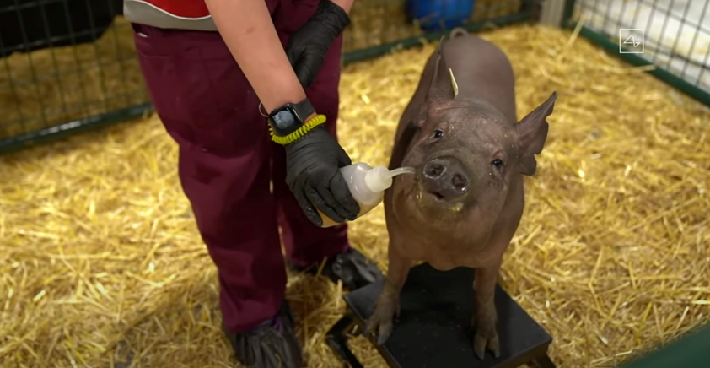
Figure 7 Gertrude, a pig used in the experiment

5.2. Human Trials and Regulatory Approvals:
As of September 2021, Neuralink had announced its intentions to conduct human trials. However, it's important to note that conducting trials involving human participants is a complex and highly regulated process. Obtaining the necessary regulatory approvals, such as those from the U.S. Food and Drug Administration (FDA), is a crucial step in this process. The trials would involve individuals with specific neurological conditions, and the primary focus would likely be on safety and efficacy.
By conducting human trials, Neuralink aimed to gather valuable data and assess the practicality of its BCI technology in real-world scenarios. These trials would represent a significant milestone in the company's journey toward realizing its goals.

5.3. Challenges and Setbacks:
Developing BCIs and advancing neurotechnology is a challenging endeavor. Some of the challenges and potential setbacks that Neuralink and similar companies may face include:
- Technical Challenges: Developing BCIs that are safe, durable, and capable of reliably interfacing with the brain is a highly complex task. Ensuring that the technology remains functional for extended periods without causing harm to the user is a significant challenge.
- Ethical and Privacy Concerns: BCIs raise important ethical and privacy considerations. Issues related to consent, data security, and the potential for misuse of brain data must be carefully addressed.
- Regulatory Hurdles: Regulatory approvals for medical devices, especially those involving the brain, can be a lengthy and rigorous process. Meeting the necessary safety and efficacy requirements is paramount.
- Public Acceptance: Widespread adoption of BCIs may require public acceptance and trust in the technology. Addressing concerns and building public awareness will be important for the success of Neuralink and similar endeavors.
- Cost and Accessibility: BCIs must become affordable and accessible to a broad range of individuals to fulfill their potential in healthcare and human augmentation.

6. ETHICAL AND SOCIAL IMPLICATIONS
Neuralink's development of brain-computer interfaces (BCIs) and related neurotechnology raises significant ethical and societal implications that warrant careful consideration:

6.1. Privacy and Security Concerns:
BCIs have the potential to access and transmit highly sensitive neural data, which raises concerns about privacy and security. Ensuring that individuals' neural information is protected from unauthorized access and data breaches is crucial. Ethical safeguards and robust security measures must be in place to protect the integrity and confidentiality of neural data.

6.2. Potential Misuse of Brain Data:
There is a risk that neural data collected via BCIs could be misused. This might involve unauthorized access to an individual's thoughts, emotions, or cognitive processes. To prevent misuse, there must be clear regulations and ethical guidelines governing the collection, storage, and use of neural data. Transparency in data practices and user consent are essential components.

6.3. Equality and Accessibility Issues:
As with many emerging technologies, there is a risk of exacerbating existing inequalities. BCIs could initially be expensive and accessible primarily to those with financial resources, potentially creating a divide between those who can afford these enhancements and those who cannot. Ensuring equity in access to BCIs and related healthcare services is a pressing concern. Addressing cost barriers, providing support for underprivileged communities, and considering healthcare disparities is crucial.

6.4. Public Perception and Acceptance:
Public perception and acceptance of BCIs play a significant role in their adoption and integration into society. Some people may be wary of the implications of merging technology with the human brain. Ethical considerations, transparency in research and development, and open dialogue with the public can help shape a positive perception and build trust.
Additionally, addressing ethical and societal implications may require regulatory frameworks that keep pace with technological advancements. Striking a balance between fostering innovation and ensuring responsible development is essential. Regulatory agencies, researchers, and industry stakeholders must collaborate to develop guidelines and standards that protect the interests and well-being of individuals while allowing for the potential benefits of BCIs to be realized.

It's important to note that as BCIs continue to advance, new ethical and societal considerations may emerge. Addressing these concerns requires ongoing interdisciplinary collaboration and thoughtful deliberation to navigate the complex ethical landscape of neurotechnology and ensure that its benefits are accessible and equitable for all.

7. FUTURE OUTLOOK:
The future outlook for Neuralink and the broader brain-machine interface (BMI) or neurotechnology landscape is filled with both promise and challenges. Here are some key aspects to consider:

7.1. The Role of Neuralink in the Neurotechnology Landscape:
Neuralink has positioned itself as a pioneering company in the neurotechnology field, particularly in the development of BCIs. Its role in the future will likely involve continued research and development, expanding the capabilities of BCIs, and seeking regulatory approvals for medical and non-medical applications. Neuralink's success could pave the way for the broader adoption of BCIs and influence the direction of neurotechnology as a whole.

7.2. Potential Applications Beyond Healthcare:
While healthcare applications, such as treating neurological disorders, remain a primary focus, BCIs have the potential for a wide range of applications beyond healthcare. These may include brain-controlled devices for daily tasks, improved communication methods, and cognitive enhancements. BCIs could also play a role in the fields of education, entertainment, and virtual reality, opening up novel possibilities for human-computer interaction.

7.3. Collaboration and Competition in the BMI Field:
The field of BMI is highly competitive and multidisciplinary, involving contributions from neuroscience, engineering, computer science, and more. Collaboration between companies, research institutions, and government agencies is crucial for advancing the field. Additionally, as the technology matures, competition among companies seeking to develop BCIs and related technologies is likely to intensify. This competition can drive innovation but also necessitates ethical considerations and regulatory oversight.

Collaboration and knowledge sharing are essential for addressing the complexities and ethical dilemmas of neurotechnology. Ethical guidelines, standards, and best practices should be established to ensure the responsible development and deployment of BCIs and to navigate the challenges related to privacy, security, and equity.

In the future, the success and impact of Neuralink and other neurotechnology companies will depend on their ability to address technical challenges, regulatory hurdles, and ethical concerns. The field is still evolving, and while there is great potential for transformative applications, there are also important ethical and societal considerations that must be carefully managed to ensure that neurotechnology benefits humanity as a whole. As developments in the field continue, it will be essential to monitor how the landscape evolves and adapts to the changing possibilities and challenges of BCIs and related technologies.

8. CONCLUSION:
In conclusion, Neuralink holds the potential to usher in transformative changes in healthcare and human-computer interaction, but it also presents profound ethical considerations that demand responsible development and thoughtful navigation.

Neuralink's innovative brain-computer interface technology has the potential to revolutionize healthcare by offering new treatment options for neurological disorders and conditions, potentially enhancing the quality of life for many individuals. Beyond healthcare, it could lead to groundbreaking advancements in human-computer interaction, enabling more intuitive and efficient communication and control of technology. This potential for transformation has the power to improve the lives of people with disabilities and open up exciting possibilities for human augmentation.

As Neuralink and similar companies advance in the field of neurotechnology, addressing ethical considerations becomes paramount. Protecting individual privacy, ensuring data security, and mitigating the risks of misuse are central concerns. Responsible development entails adhering to ethical principles, maintaining transparency in research and development, obtaining informed consent from participants, and collaborating with regulatory bodies to establish clear guidelines. It also involves addressing issues of accessibility and equity to ensure that the benefits of BCIs are available to a diverse population.

The future of Neuralink and the broader field of brain-machine interfaces (BMIs) holds great promise, but it is also marked by challenges. The success and impact of Neuralink will depend on its ability to overcome technical hurdles, navigate regulatory complexities, and build trust among the public. Collaboration with the scientific community and ethical vigilance will be critical. As BCIs continue to evolve, the landscape of neurotechnology will shape the way we interact with technology, treat neurological conditions, and possibly even enhance human capabilities. The responsible development and thoughtful integration of these technologies into society will be key factors in determining their long-term impact.

9. RFERENCES:
- Musk, "Neuralink: An Integrated Brain-Machine Interface Platform With Thousands of Channels", J Med Internet Res, vol. 21, no. 10, Oct 2019.
- Sarah Marsh, "Neurotechnology: Elon Musk and the goal of human enhancement", The Guardian, January 2018.
- https://www.ncbi.nlm.nih.gov/pmc/articles/PMC6914248/
- https://www.nytimes.com/2022/11/30/health/elon-musk-neuralink-brain-device.html
- https://www.thehindu.com/sci-tech/science/neuralink-elon-musk-fda-concerns-human-clinical-trials/article66915151.ece
- https://www.jmir.org/2019/10/e16194/
- https://www.bbc.com/news/health-65717487
- https://neuralink.com/

